WELCOME

Muthurangam Govt. Arts and Science College (A)
Vellore

Build an event management system using salesforce

Submitted By
- ANBU S (Leader)
- AKASH B (Member)
- AMEER HAMZA S(Member)
- ARUNKUMAR G (Member)

TRAILHEAD URL LINKS;

Team Leader (ANBU S) : https://trailblazer.me/id/anbus15
Team member 1 (AKASH B) : https://trailblazer.me/id/aakash371
Team member 2(AMEER HAMZA S):
Team member (ARUN KUMAR G) : https://trailblazer.me/id/akumar8244

The following steps are used to create the event management app:

Milestone 1

STEP 1: To creating the developer account first so, go to the developers salesforce.com click
the page will be opened. Enter the required details like as name, email etc…
the mail will be received with user name. The shown Fig(1)
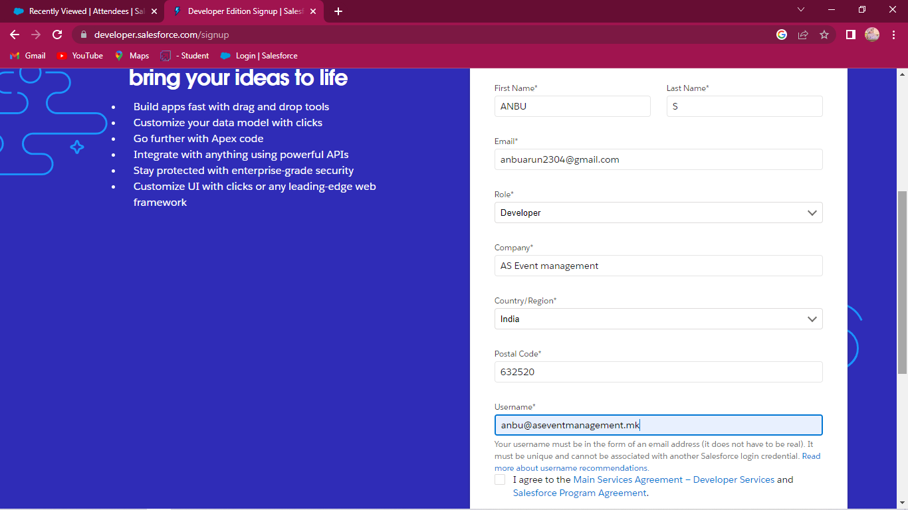
Fig(1)
STEP 2: Opened the received mail click the verify option and generate the Strong password.
This will be shown in the Fig(2)
Fig(2)
STEP 3: Now go to the Salesforce.com and enter the valid username and password the new
tab Setup will be opened it will be shown in Fig(3)

Fig(3)
Milestone 2

CREATION OF OBJECTS FOR EVENT MANAGEMENT

Step 4: We create to four objects for Event Management: i.e. Events, Attendees,
Speakers and Vendors.

Now create Events Object. First go to object manager and click new object for create object.
- Next enter Label; Event
- Plural Label; Events
- Record Name; Event Name
- Next scroll down and the allow Reports and Search box click and save.
This activity shown in given figure.
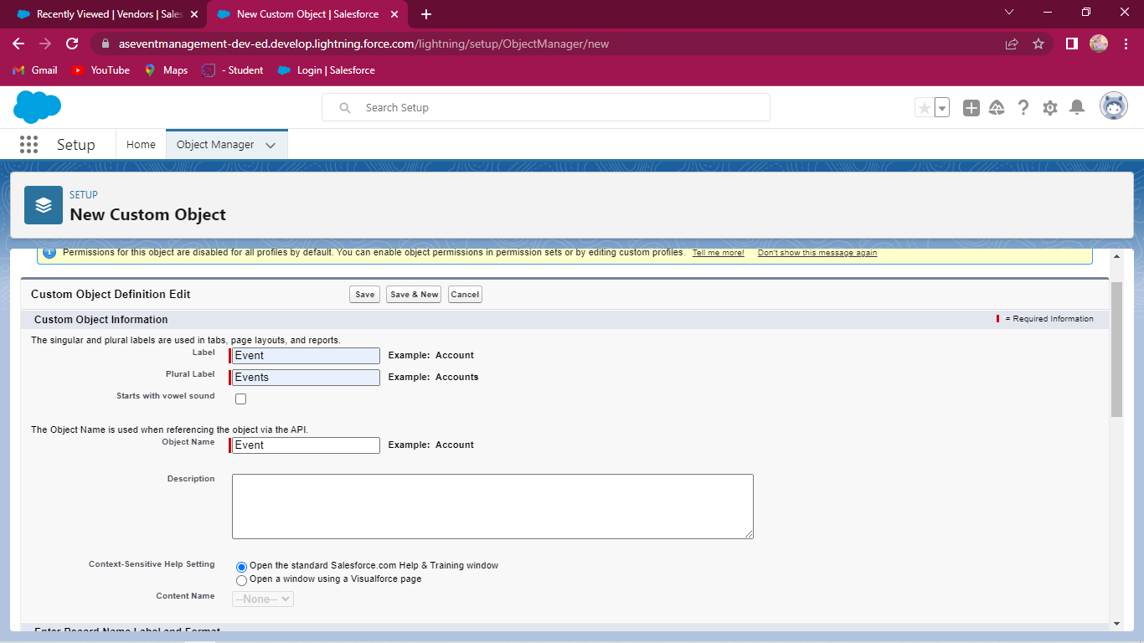
Event Object creation

Follow the above procedure and create the Attendees, Speakers and Vendors Objects. This activity is shown given figures.
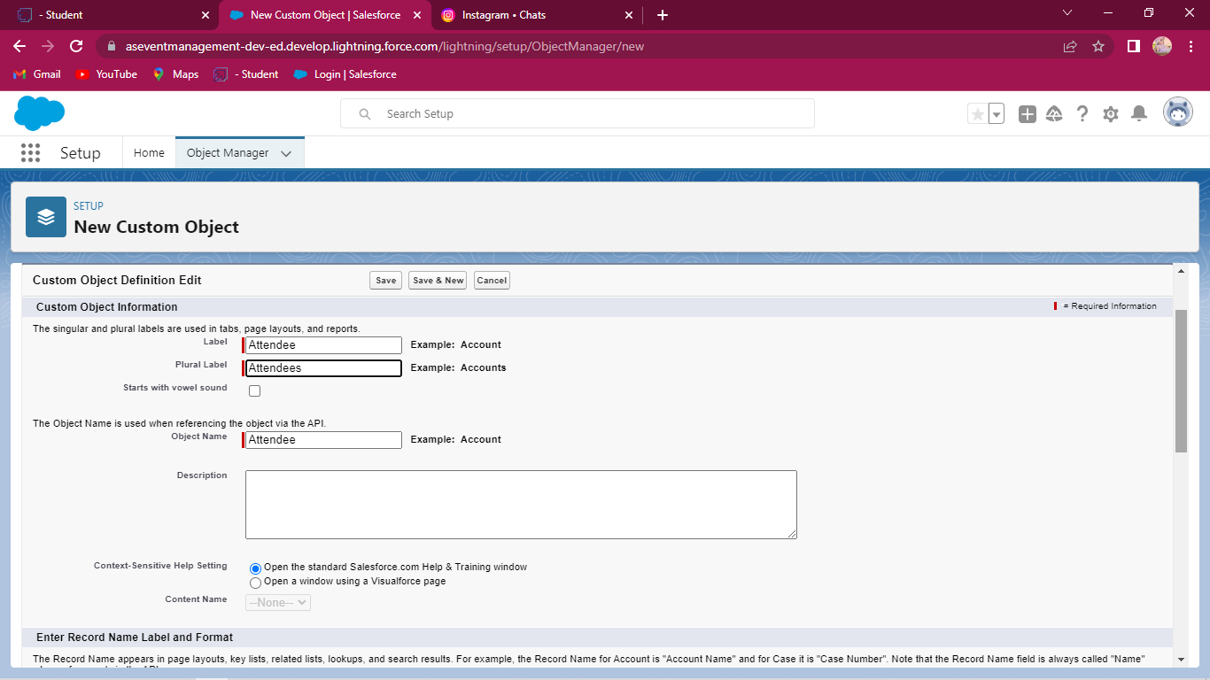
Attendees Object creation

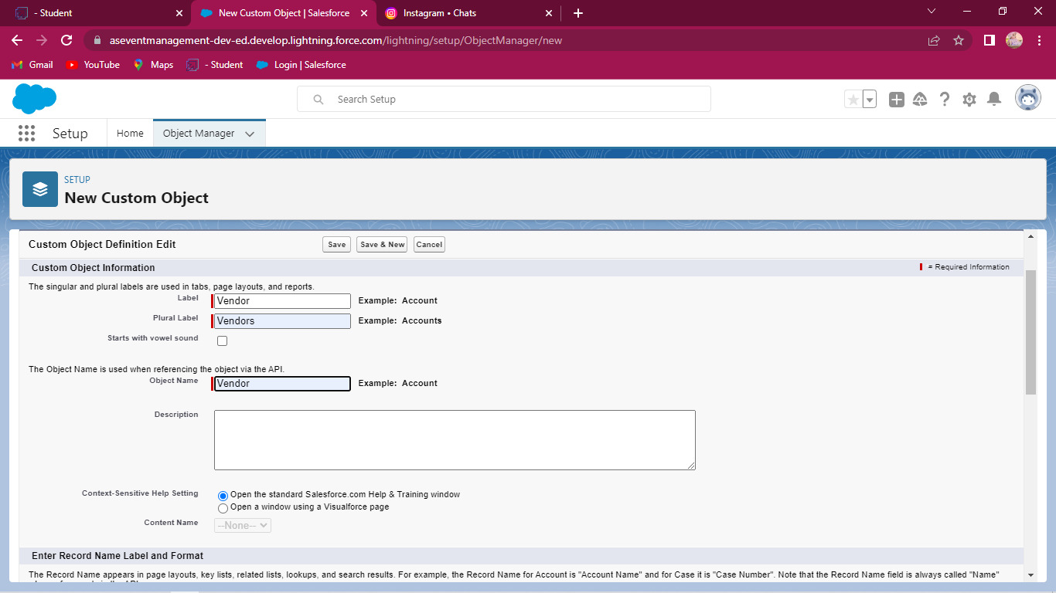
Vendors Object creation
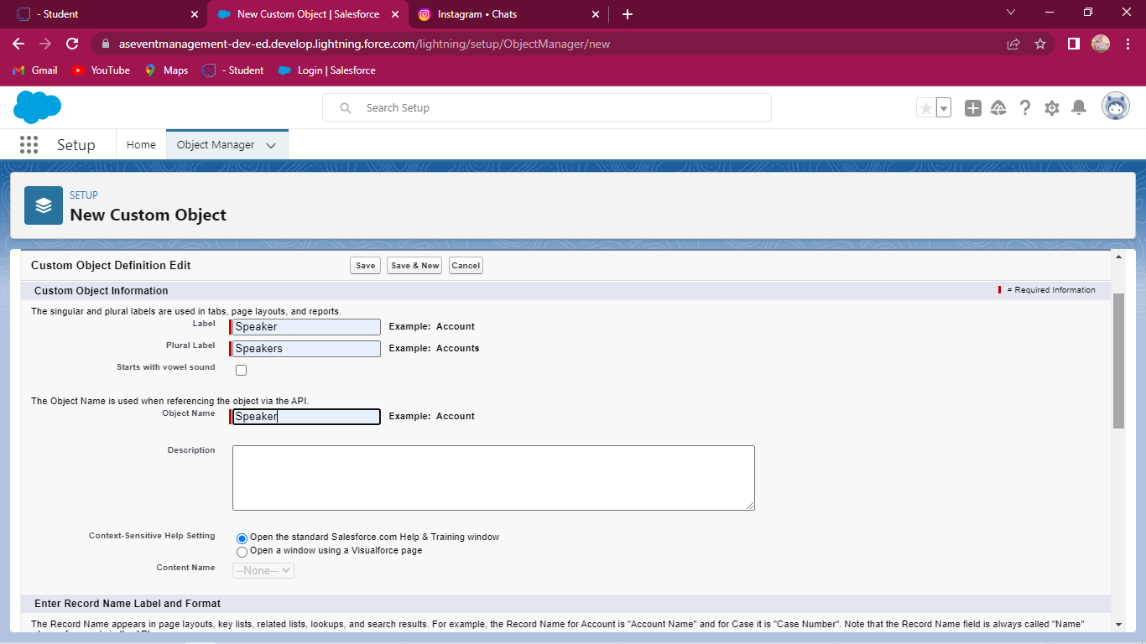Speaker object creation
Step 5: Creation of tabs for Event Management.
We are create four tabs for Event management. i.e. Event tab, Attendees
Tab, Speaker tab and Vendor tab.
Now we create Event tab. First go to home page and search Tabs in Quick Find on the left side top and select Tabs.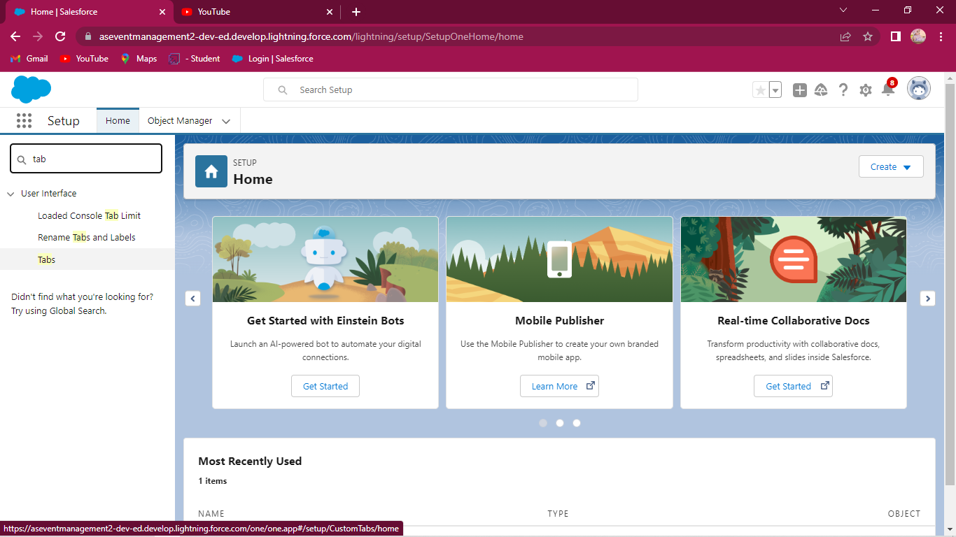
Click new and select object Event and also select icon for this tab. Click
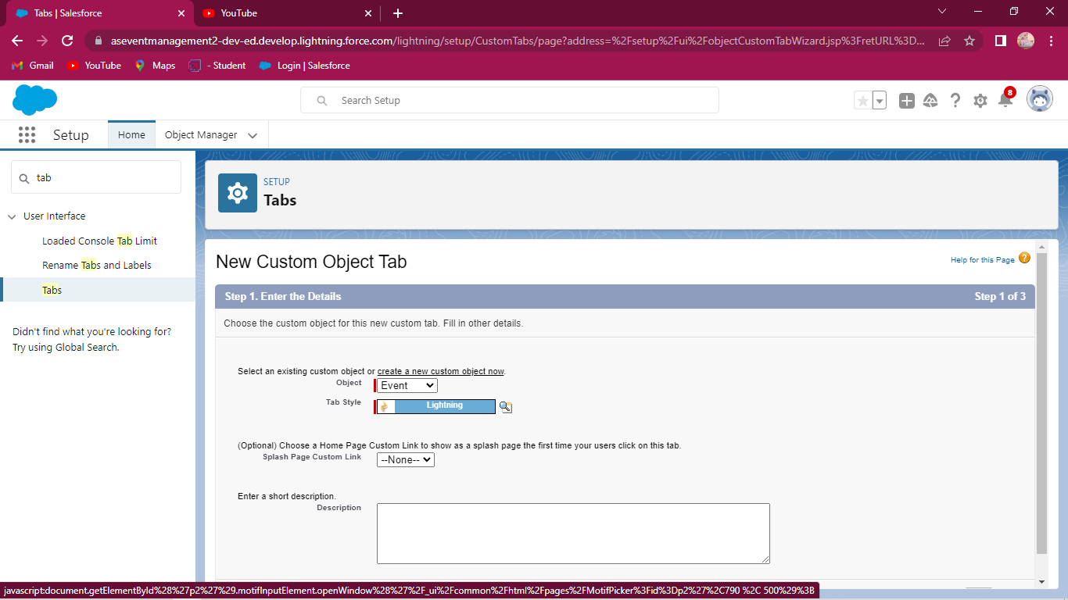
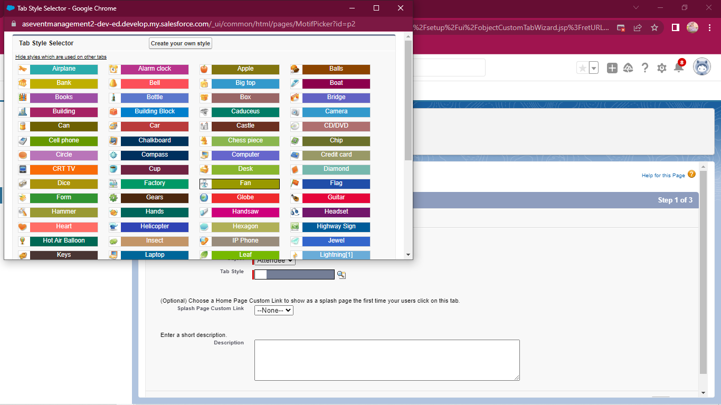
Next button and leave all defaults and save. This activity shown given figure.
Like this we create Attendee tab, Speaker tab and Vendor tab.
Milestone 3

CREATION OF APP FOR EVENT MANAGEMENT
Step 6: Now we search App Manager in Quick find box in setup page left side top and select App Manager.
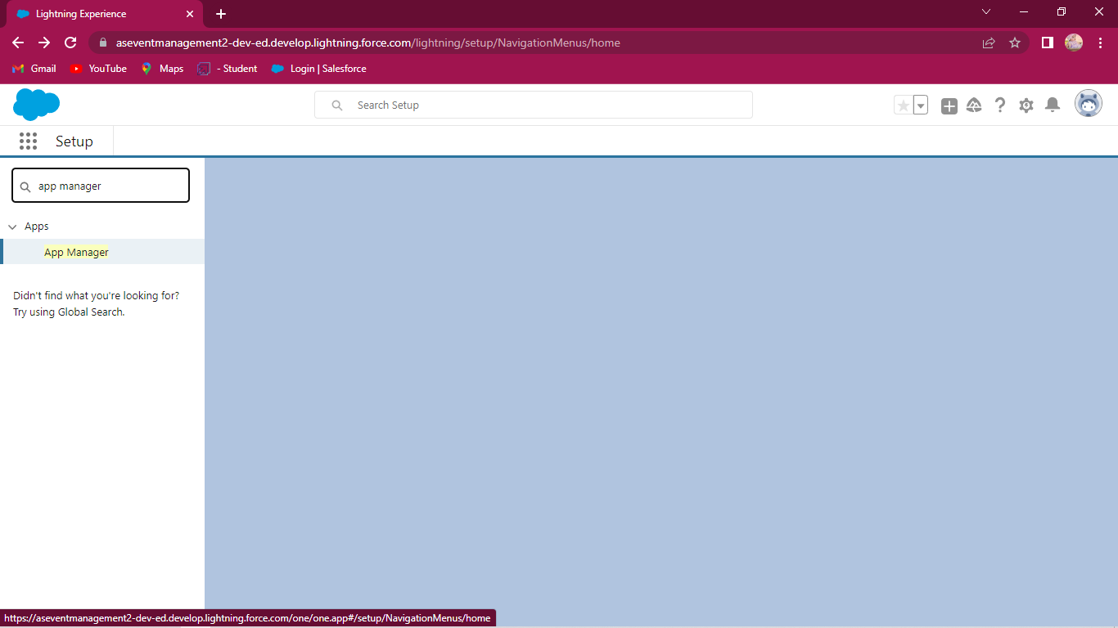

Click new lighting app and next enter Event Management as the app name and click next and others as default selections and click next button.
Now we select Events, Attendees, Speakers, Vendors, Reports and Dashboards are selected and move the items and click next.
Then Profiles select system Administrator are selected and move the items and click save and finish.

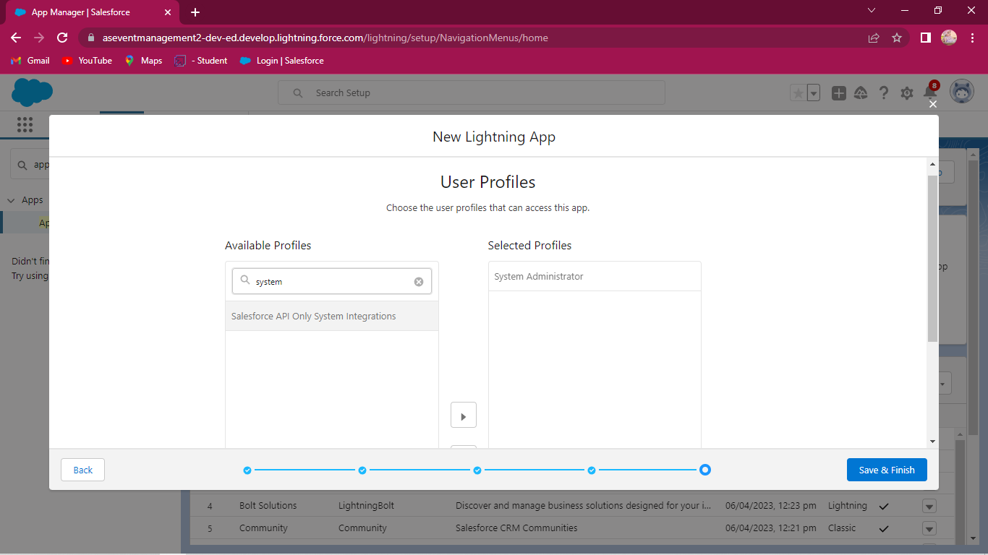
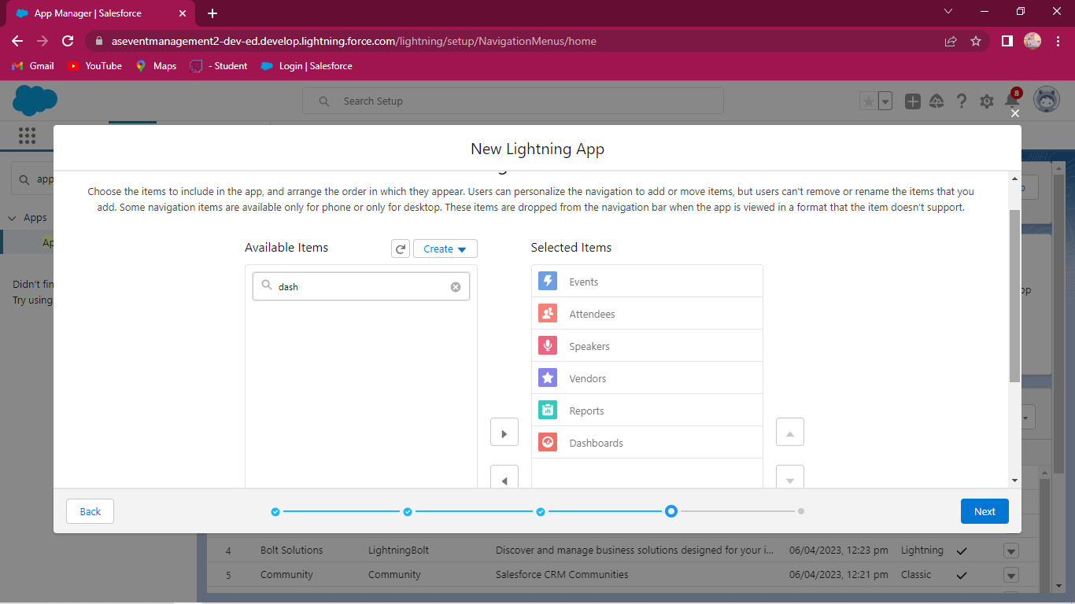

Milestone 4
CREATION OF FIELDS FOR THE EVENT OBJECTS
Step :7 Now go setup page and click object manager and select Event Object next click Field & Relationships from the left navigation and click it.
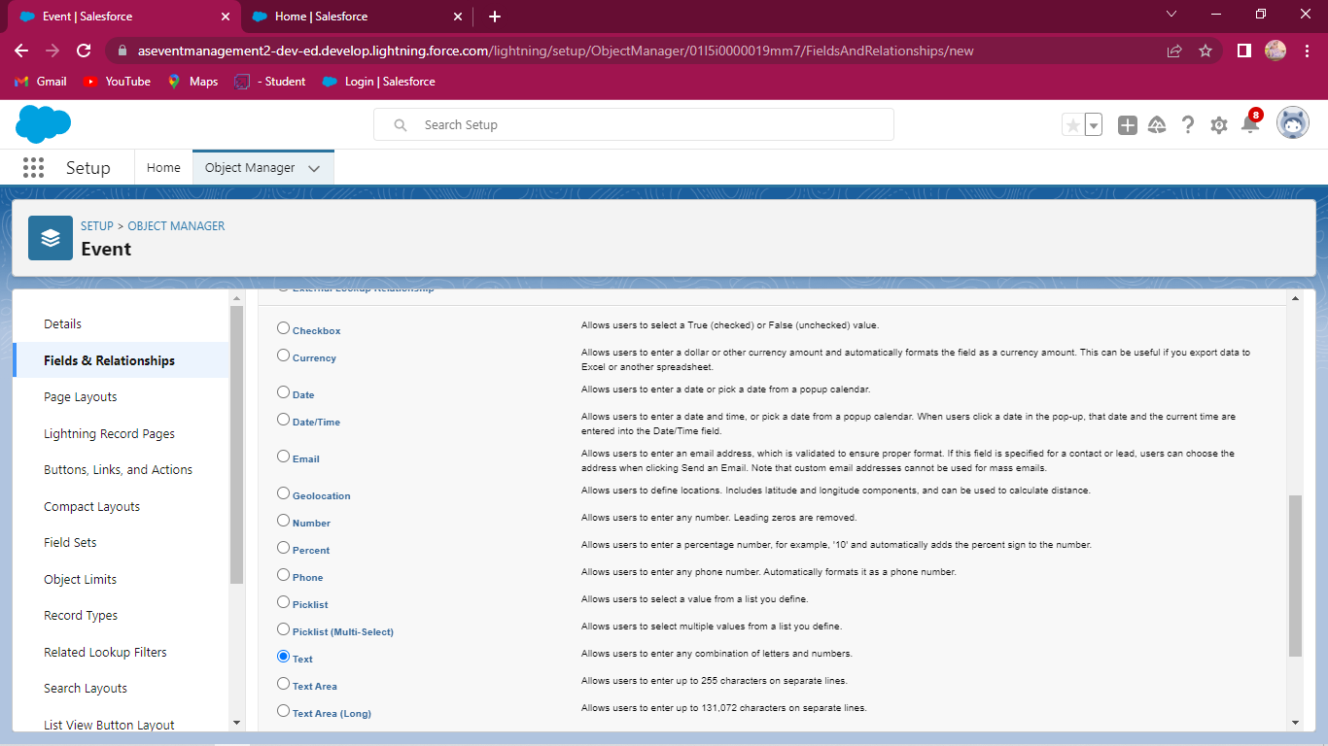
Now click new and select data type to text and click next. Enter Field Lable it City and click next and save.
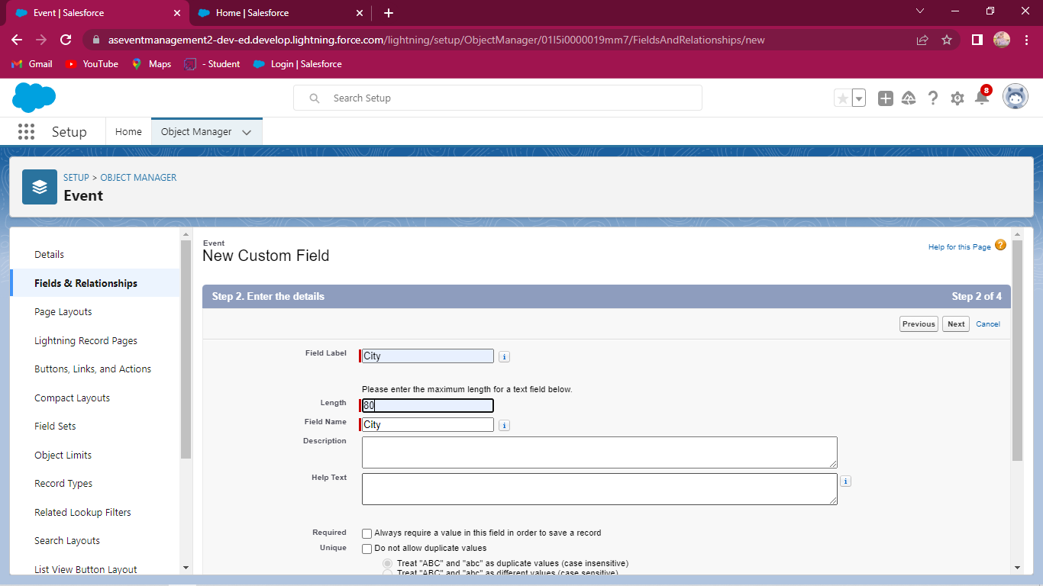
Event field creation
Event field creation

Like this now create data type Date/Time for Start date field and End date fields.
CREATION OF FIELDS FOR ATTENDEES OBJECTS

Now click setup and click object Manager and select Attendees object and click Field & Relationships and click it. Next click new and select data Type Date for Id field and save it.
Like this we create data type Phone for Phone field, data type Email for Email field, data type Pick list for Tickets and data type detail relation ship
for Event field.
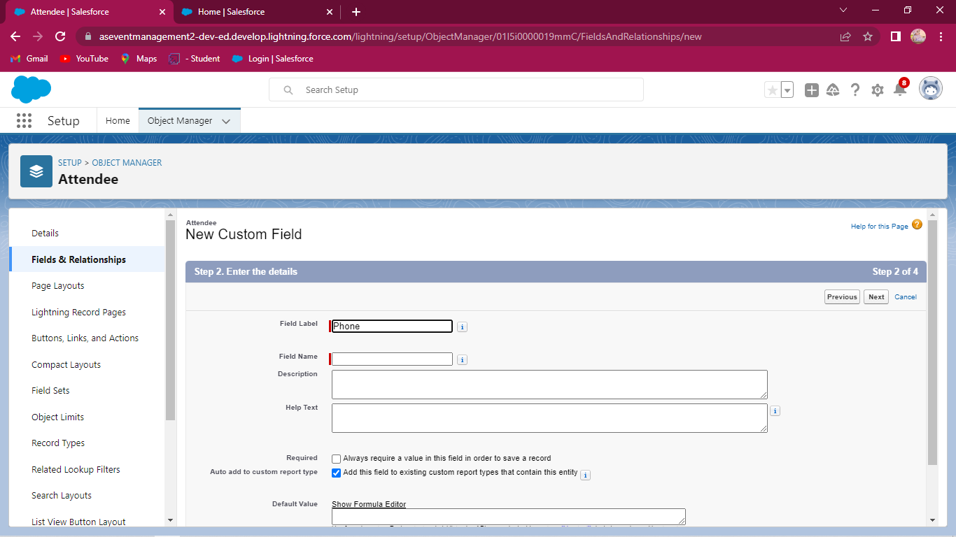
Attendees field creation
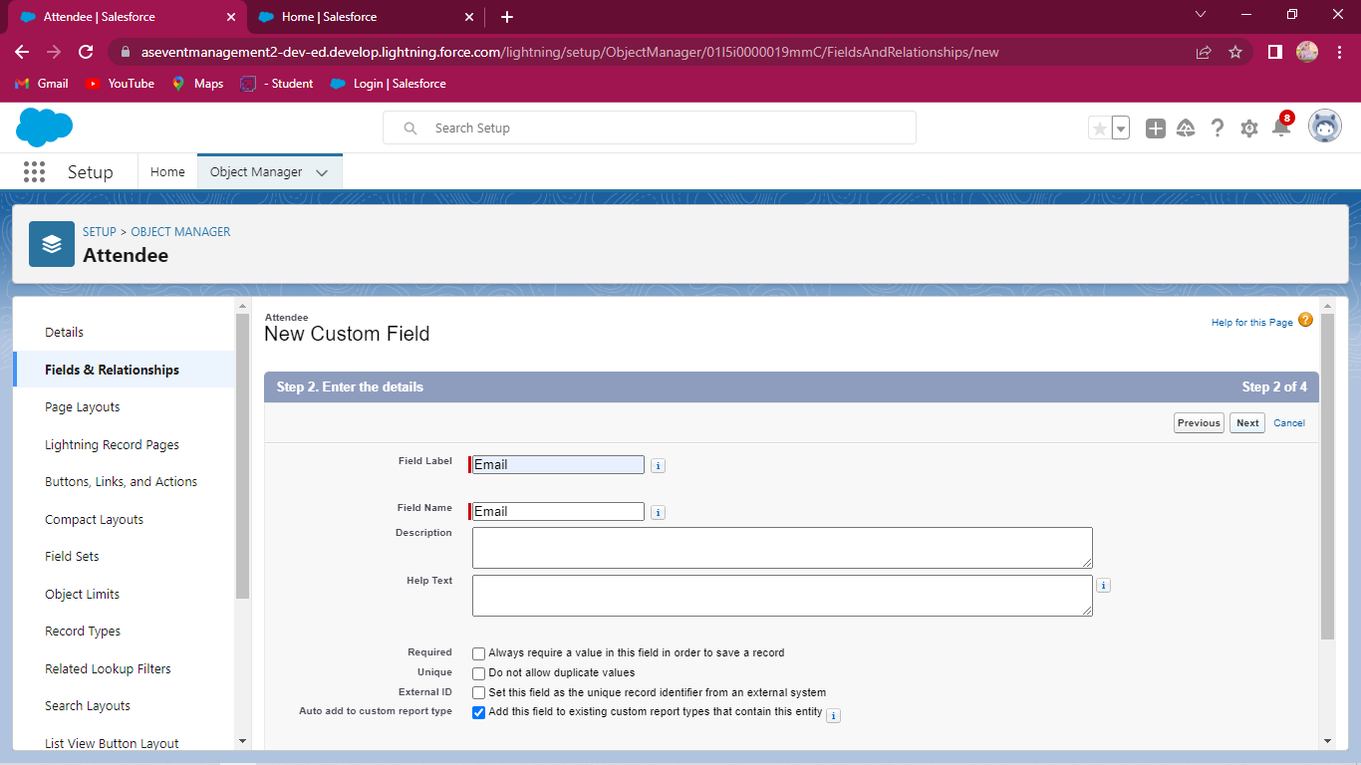
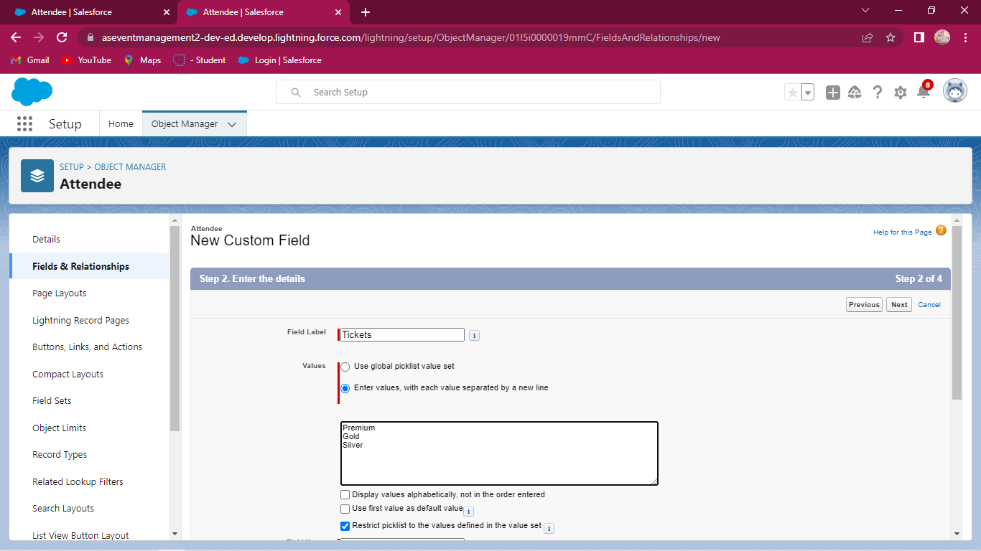
Attendees fields creation
Attendees fields creation

CREATION OF FIELDS FOR SPEAKERS OBJECTS
Step 9: Follow the above steps and select the speakers object and click new
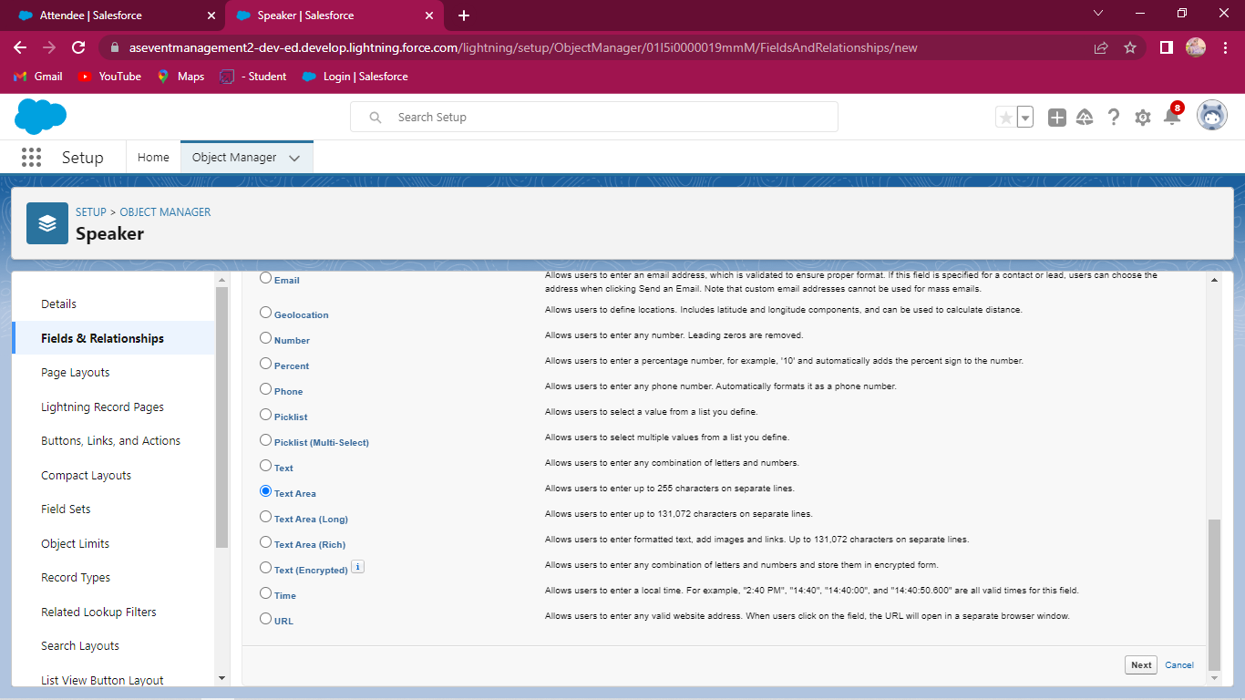
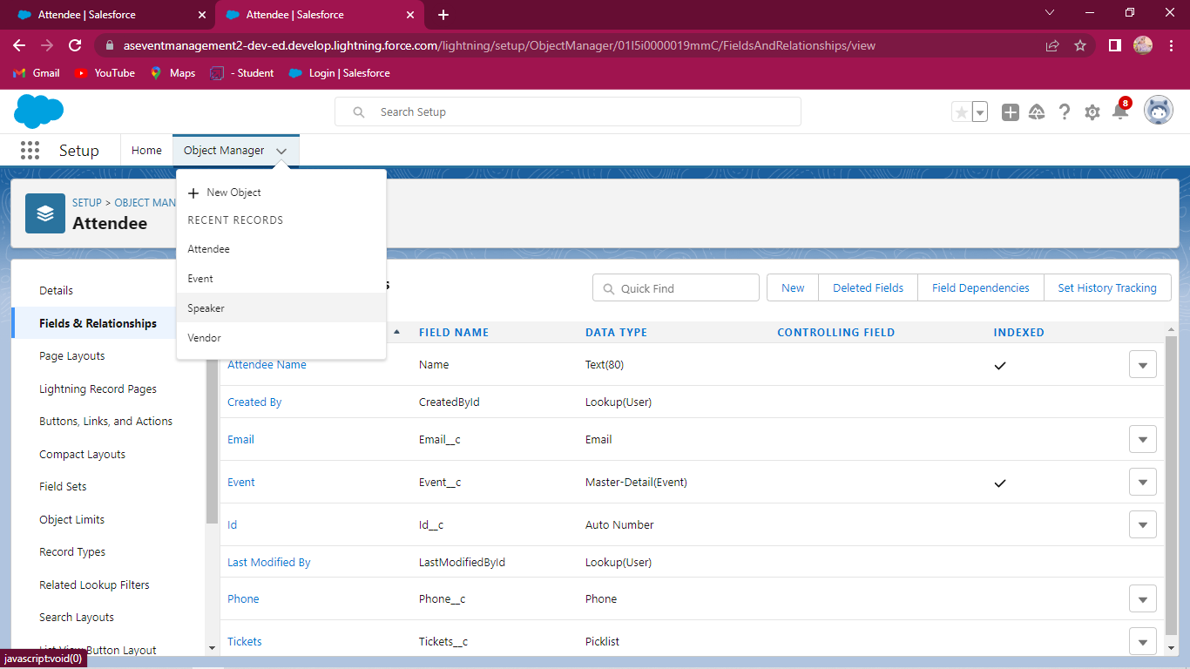
Select Field & Relationships and select data type text area for Bio field and create Email field and event field also.

Milestone 5
CREATION OF PROFILE
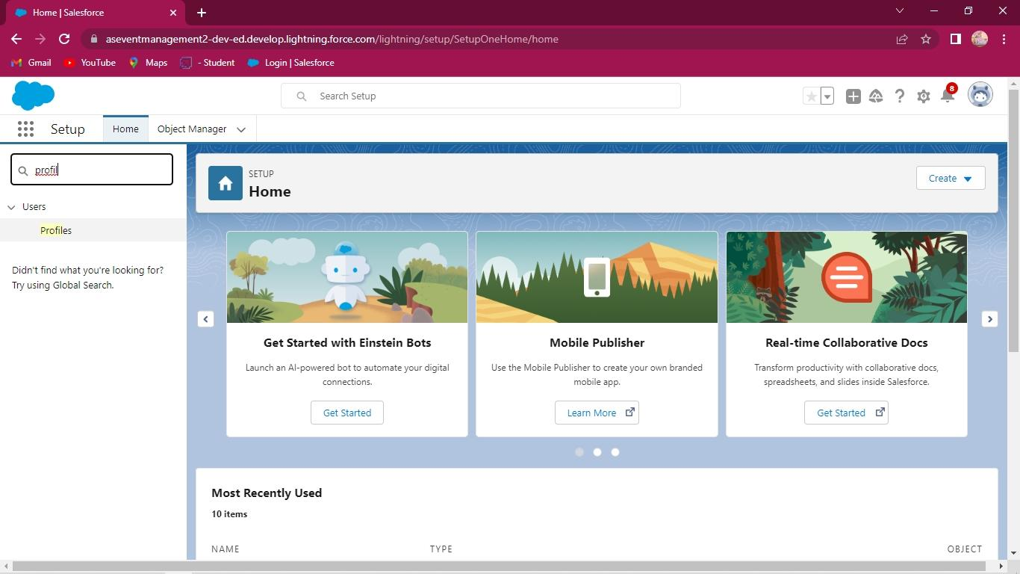
Step 10: We go to setup page and search profile in Quick find box on the left side and select profile next click standard profile and clone it.

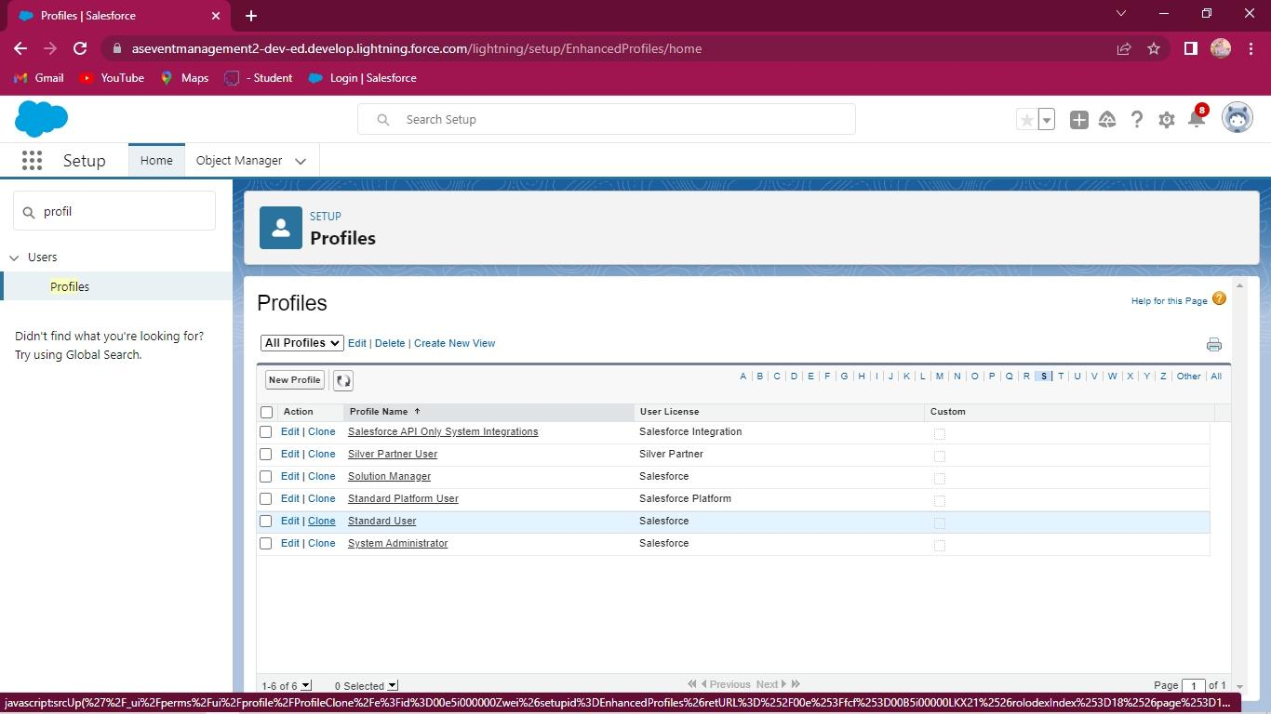
Creation of profile
Creation of profile

Enter Profile name is Event user profile and click save button. Next edit this and scroll down and go custom object permission allow to access view all permission in Events, Speaker, Attendee and Vendors.
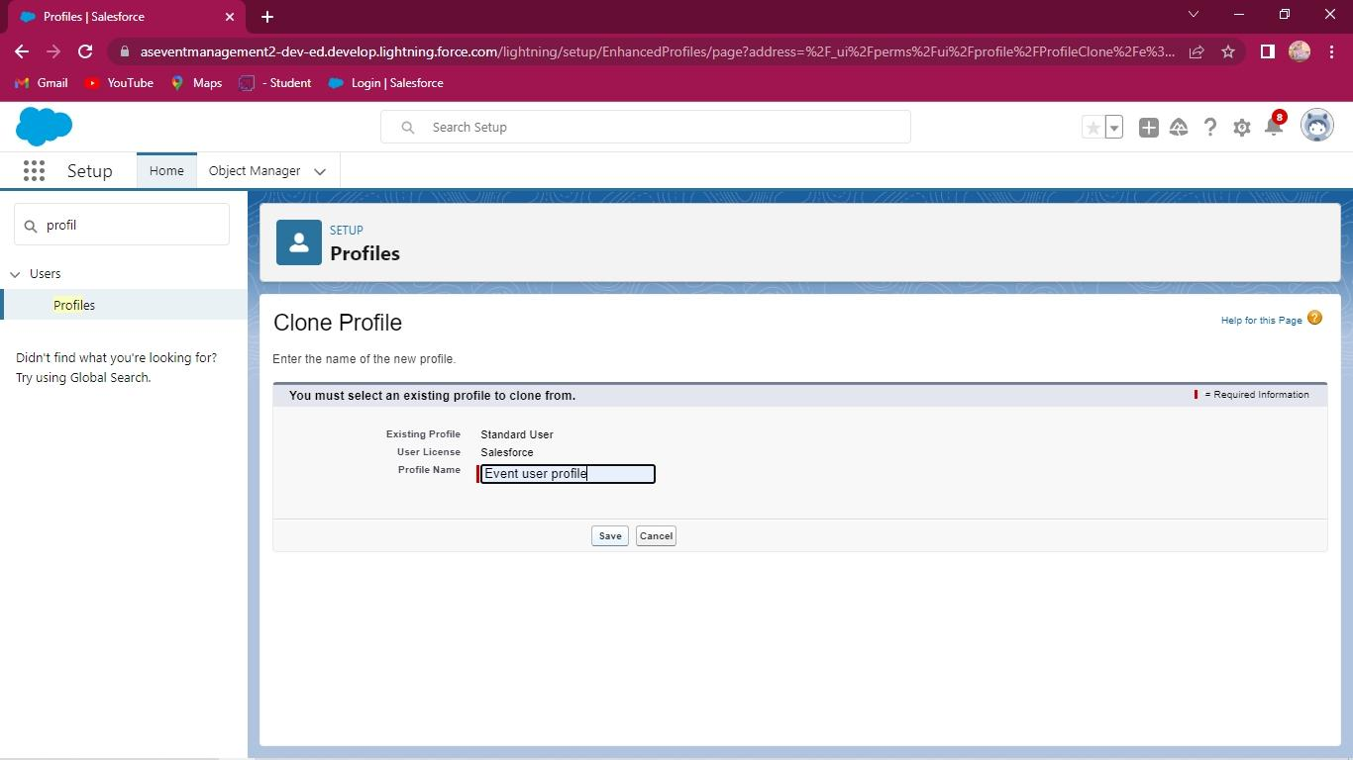
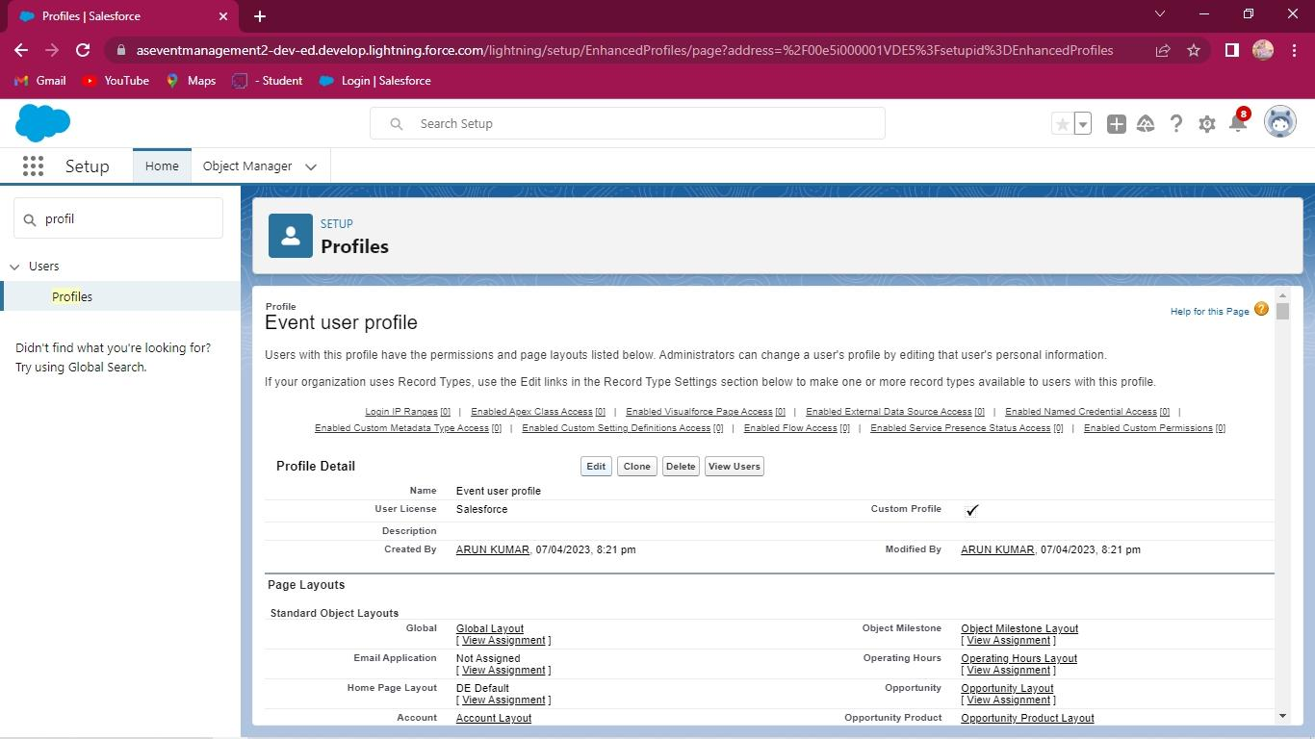
Creation of profile
Creation of profile
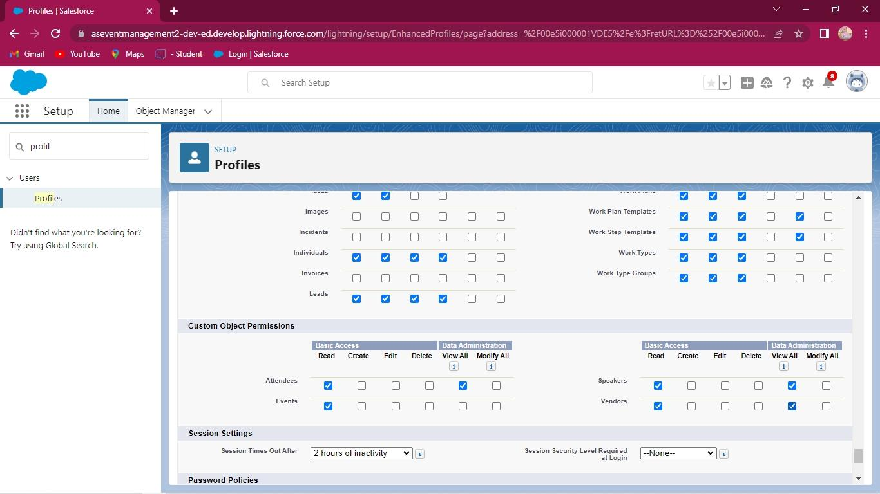
Creation of profile
Like this above procedure create Event Vendor Profile also.

Milestone 6
CREATION OF USERS
Step 11: Now we go to setup page and search in Users in Quick find box on the left side and select it and click new user.
Next enter below details and click save.
• First Name: Sanjay
• Last Name: Gupta
• Alias: Sanj
• Email: anbuarun2304@gmail.com
• Username: anbu@mk.as
• Nickname: Sanju.
• Role: leave it as default
• User License: Salesforce
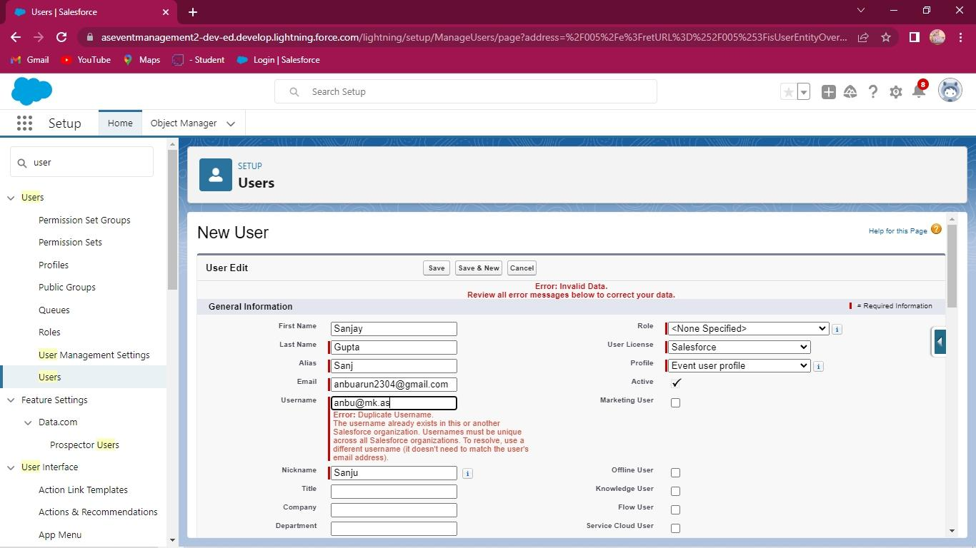

Milestone 7
CREATION OF PERMISSION SET
Step 12: go to set-up page and search permission set in Quick find box and click it. Next enter Label as Event permits and click save.
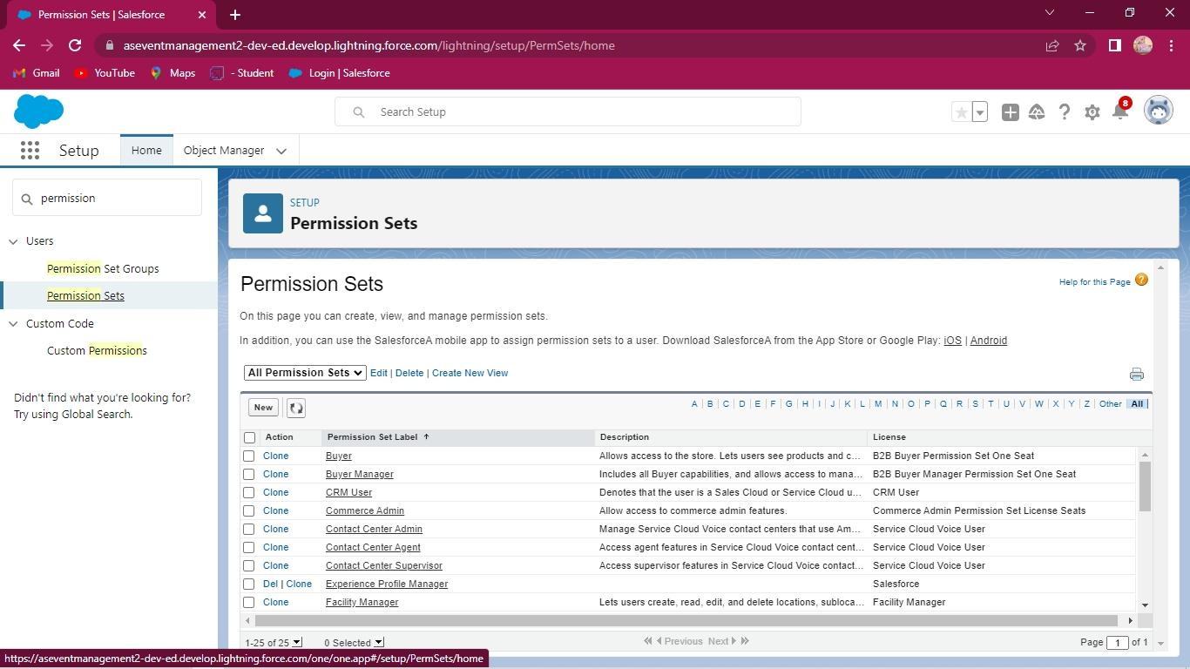
Next we select Manage assistant button and click add assignment and now select users and save it.
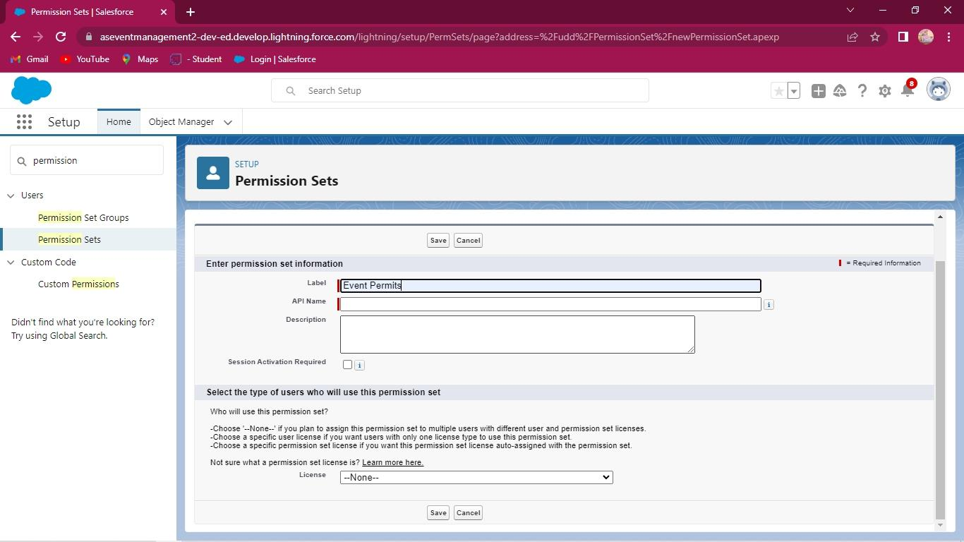
Creation of permits set

Like this above steps now create Vendor permits and save it.

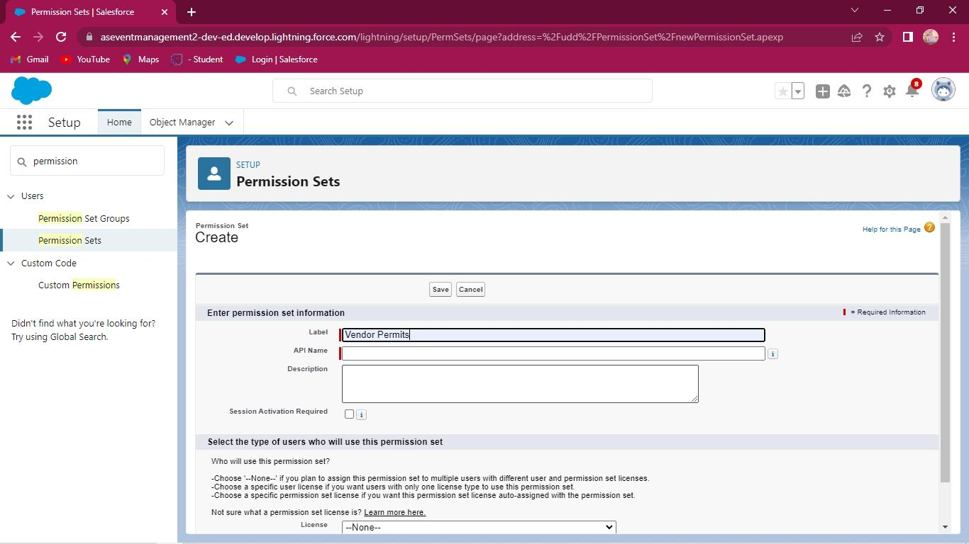
Creation of permits set

Milestone 8
CREATION OF REPORTS
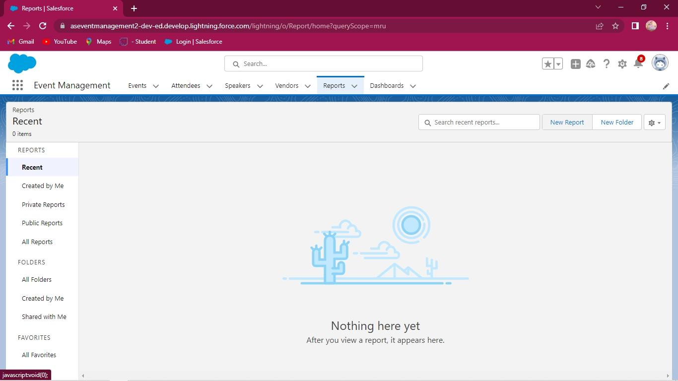
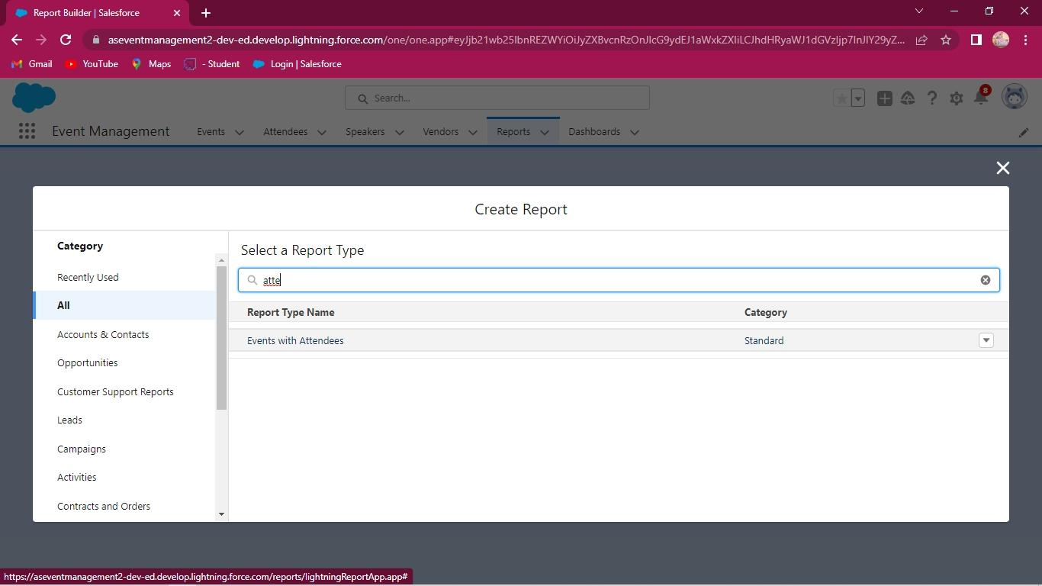
Step 13: Now we create reports for event management. Search we create app in app launch and launch the app and go to reports tab click and click new reports and select type is events with attendees click it and customise the report and click save.
Creation of reports
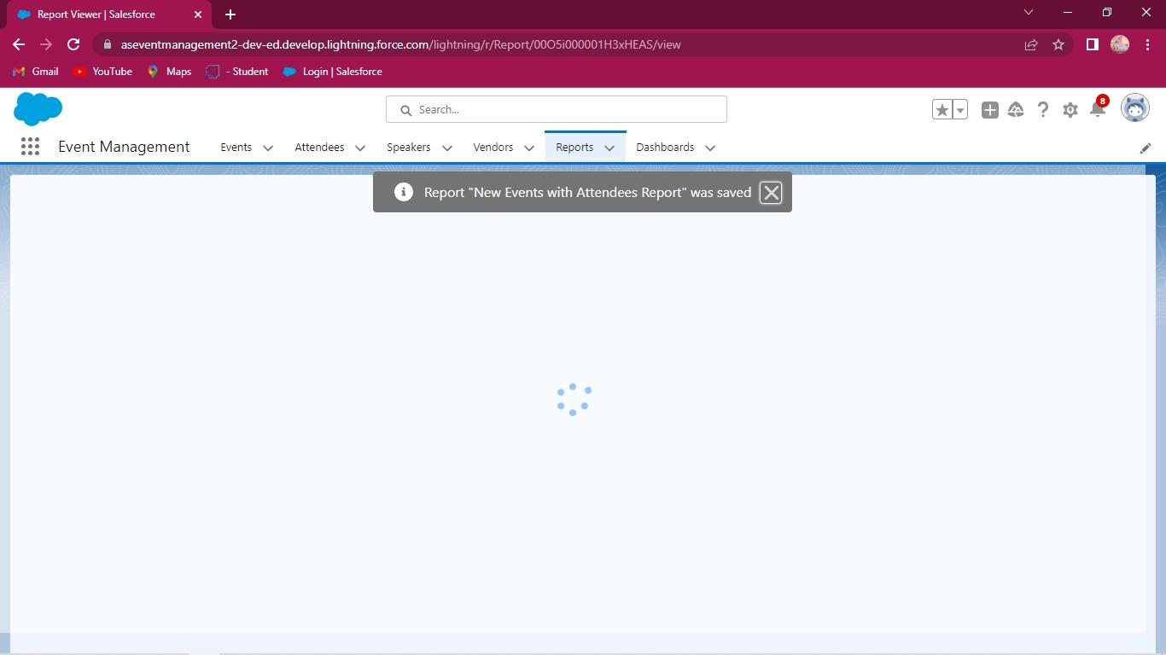
Creation of reports

END

THANK YOU

